**P6 – Design computer animations using different animation techniques**

[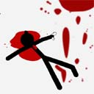](http://www.google.co.uk/url?sa=i&rct=j&q=&esrc=s&source=images&cd=&cad=rja&uact=8&ved=0CAcQjRw&url=http://www.digyourowngrave.com/stickman-madness/&ei=PxBSVar3MrHB7AaCooGwDw&bvm=bv.92885102,d.ZGU&psig=AFQjCNFOWTKw0VFkdcslLHbnZPZf_N0lSA&ust=1431527832291182)[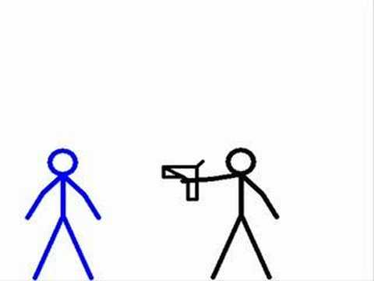](http://www.google.co.uk/url?sa=i&rct=j&q=&esrc=s&source=images&cd=&cad=rja&uact=8&ved=0CAcQjRw&url=http://www.youtube.com/watch?v=3k558KH6aQU&ei=GxBSVePKAYOy7Qb2qoDoAw&bvm=bv.92885102,d.ZGU&psig=AFQjCNFOWTKw0VFkdcslLHbnZPZf_N0lSA&ust=1431527832291182)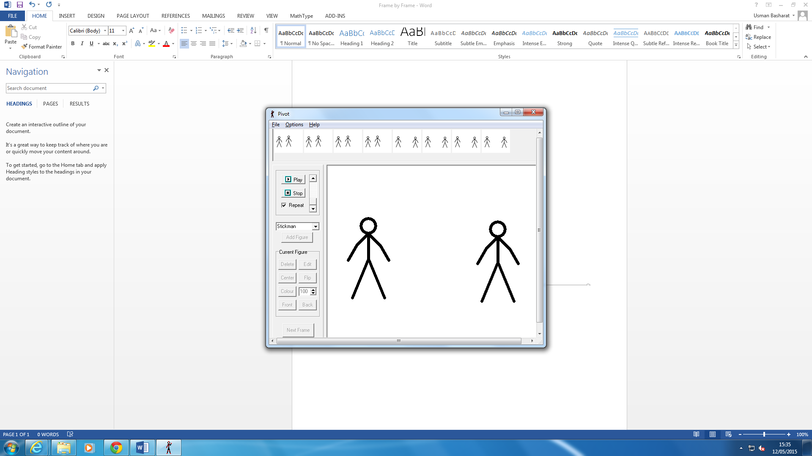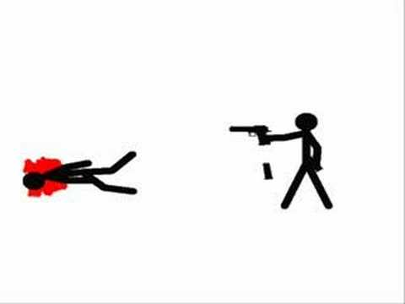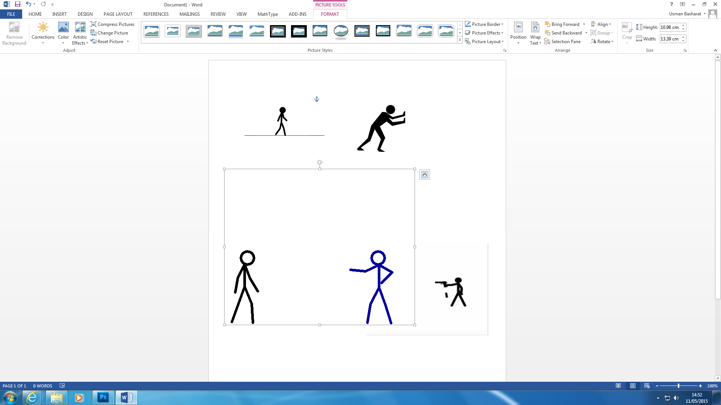**Storyboard**

A warrior gets his gun to threaten the helpless slave. The slave was scared.

This frame is one warrior and one slave standing next to each other.

He left without any answers.

He wanted to find answers but left with nothing, therefore he decided to shoot the slave.

**Structure Diagram**

**Linear**

Start

One warrior and one slave standing

End

The warrior leaves the slave’s body

End

The warrior shoots the slave

Main

The warrior is looking for some sort of information

Main

The slave is panicking and very scared

Start

The Gun is pointed at the slave.